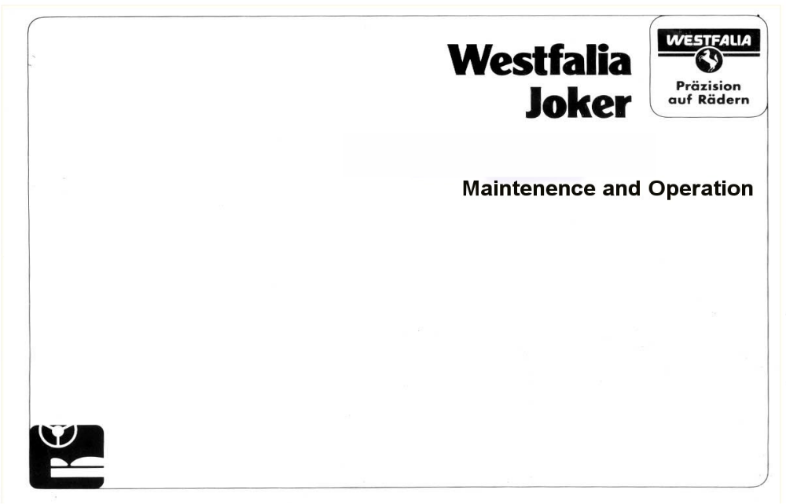

Translation Arranged by Romano Ditoro
Contents
Introduction

- Basics
  - Heating / Clock
  - Liquids
  - Gas Cooker
  - Dashboard
  - Fridge
  - Electrics
  - Water Source & Disposal Unit
  - Seats & Beds
  - Tables
  - Roof
  - Curtains
  - Furniture Storage

- Care of Interior
  - Heating
  - Gas Cooker
  - Fridge
  - Second Battery (Leisure Battery)
  - Water Source & Disposal Unit
  - Curtains / Carpets
  - Furniture
  - Roof
  - Windows
  - Application Outside
  - Joints & Hinges
  - LP Gas Tank
- Technical Details
  - Heating
  - Fluids
  - Fridge
  - Electrics
  - Water Source & Disposal Unit
  - Driving

- Self Help
  - Heating
  - Fridge
  - Battery Charger
  - Water pump
  - Insurance

- General Instructions
  - Journey Preparations
  - Loading & Tyre Pressure
  - Prior to a Journey
  - Journey Tips
  - Information for Use in Winter
  - What to Do in Bad Weather

- Appendix
  - Speakers

Introduction

This introduction contains important information about the internal features of your automobile. You should read this prior to use, so you understand the mechanisms and can use it properly.

Knowledgeable use and care for the upkeep of the van is also usually a pre-requisite for insurance claims. Further information about insurance is available from your dealer.

This manual is valid for all Joker models. Please therefore note that not all Joker models will contain all the features detailed in this manual.

The V.A.G Partners for VW Automobiles are available for the service of your Westfalia Camper Van. They can provide Westfalia replacement parts and repairs.

Please see your dealer for a detailed service, if required.

V.A.G firms are familiar with the Westfalia insurance terms

Equipment in the Westfalia Camper Van such as heating, fridge, and gas cooker are looked after by authorised service departments of the equipment manufacturers, in terms of repairs.

You can find further service points in your Westfalia pack. Further information eg: about service levels abroad, can be requested from the central customer service department of the Westfalia-Works KG, 4840 Rheda-Wiedenbruck, Telephone 05242 / 152 19
- Basics
  - Heating / Timer

Heater
Use the panel below to control the temperature.
The vents must be kept open and clear. The fan can also be used without heating to circulate air throughout the vehicle.
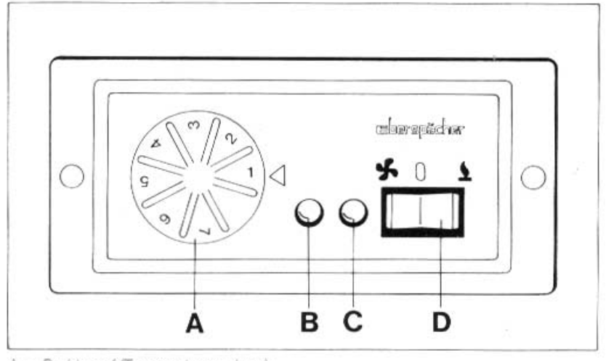
A = Dial (Regulation of Heating)
B = Red Control Light (Interference due to Overheating)
C = Green ‘On’ Light
D = Switch – Heat / Air Conditioning – On/Off

Heating:
To Switch On
- Press Switch (D) to the right
- Turn dial (A) to Number 7
- The green control light (C) will come on and the heating will start
As soon as the temperature reaches the desired level, turn the dial (A) back until the green light (C) goes darker. Doing this will keep the heating constant at the desired level. The space between each number on the dial (A) corresponds to about 5 degrees Celsius.

To Switch Off:
Turn switch (D) to the middle setting. The green light (C) will turn off. The fan will continue running until the heater has cooled down, and will then switch off automatically.

Air Conditioning / Circulation of Air:
To Switch On
Press switch (D) to the left. The green light (C) will turn on and the fan will begin to work.

To Switch Off:
Turn switch (D) to the middle setting. The green light (C) will turn off.

Warning !
You can avoid the smell of the heating by closing the window on the left side of the vehicle

Instruction:
The heating must be switched off in enclosed spaces (eg: in ferries) or when filling with petrol/diesel.
Clock
It is not necessary to switch on the ignition before using the clock. The display constantly shows the time.
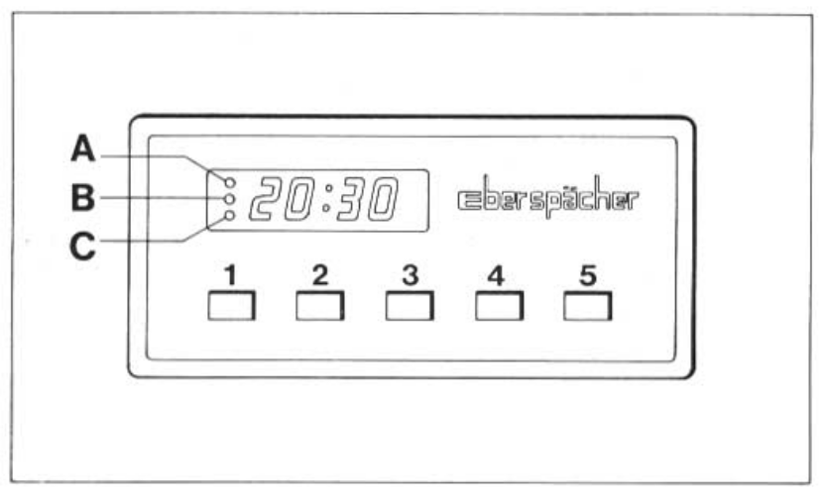
To Set the Time
- Press button 1 and either button 4 or 5 at the same time

To Switch on Heating: (possible to be independent from the previous choice)
- Press button 3, the possible heating time will appear in the display in minutes
- Set the temperature with the regulator

To switch the on the heating for long term use:
- Press buttons 1 & 3 at the same time
- The display will show 00

To Switch off Heating:
- Press button 3
- The fan will continue to run until the unit has cooled, and then will switch off automatically

The display allows you to choose 3 different times for the heating to come on. After pressing button 2 once, twice or three times, memories A, B, or C will be displayed.

You will reach the neutral position by pressing button 2 again. The time will show and the memory will be saved.

Setting Pre-Set Times:
- Press button 2
- Memory lights up (either A, B, or C will light up)
- By pressing button 4 & 5, the desired pre-set time will be saved in the memory of A, B or C.

To Erase Pre-Set Times:
(Heating switches on at a pre-set time)
- Press button 2.
- Memory lights up (A, B, or C)
- Pre-Set time appears on the display
- After 20 seconds, the actual time appears on the display.

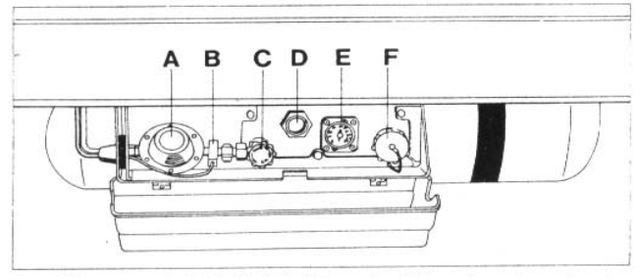
The stopper vent (F) is located under the cover of the gas tank.

1.2 Fluids

Gas Tank
The LPG tank can be found on the left side of the vehicle, under the body of the vehicle, and can be identified by its red colour.
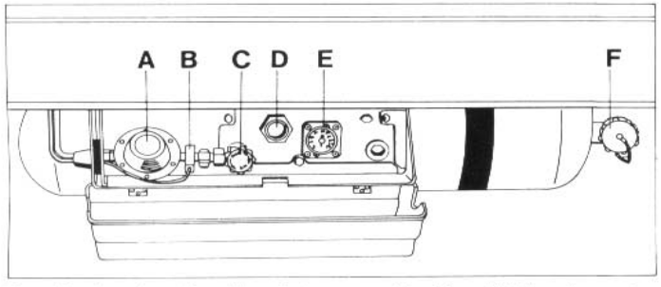
A = Pressure Control C = Main Vent E = Volume Level
B = Ice – Ex D= Safety Vent F = Fill Up Point

Only fill the tank with DIN 51621 propane fuel from licensed petrol stations at home and abroad.

Petrol for using the vehicle is normally identical in its composition to the propane gas used for the household and camping.
To Fill the Tank
- Open up the fill up point (F)
- Put in LPG nozzle and fill up tank

There is an automatic switch which will prevent any more LPG going into the tank, once it is 80 % full

The tank’s volume level display (E), which is behind the lockable cover shows values in percentages.

Determining the amount of LPG remaining in the tank
With the diagram below, you can determine the volume of LPG in kilograms and litres from the displayed percentage

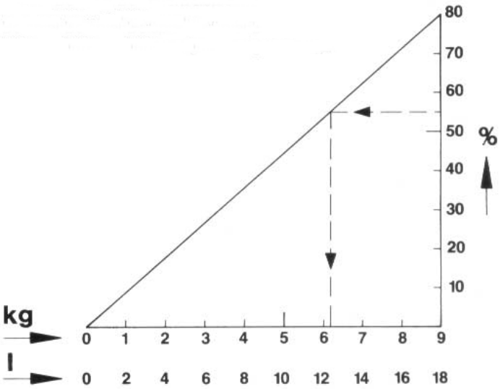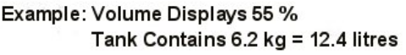
Pressure Control With the 3 Way Vent
The pressure control reduces the container pressure on the components through its usage, by 50 Mbar.

A container of gas or an external gas source can be joined on to the fast lock (A). Before you do this, you should take off the protective cover (B).

The security of the LPG lead can be threaded through the fast lock (A), but you need to watch the setting 3.

Settings For The Vents C & D

Setting 1:
Delivers LPG from the LPG tank to the equipment which uses LPG in the vehicle

Setting 2:
Delivers LPG from the LPG tank to the equipment which use gas outside of the vehicle - at the same time delivers gas where needed inside the vehicle.

Setting 3:
Emergency lead for an external LPG tank

Setting 4:
No LPG use / delivery
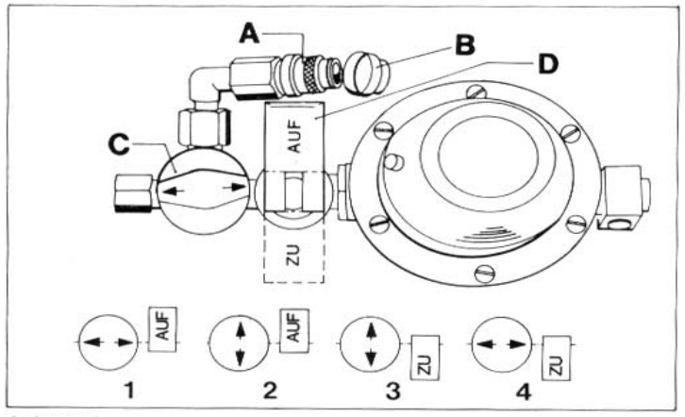
Warning !

- The settings of the fast-lock (A) cannot be changed
- Watch the settings of the vents C & D

De-Icer

The De-Icer protects the LPG pressure regulator. With external temperatures of +5° Celsius or less, you should switch on the De-Icer from the display (via the switch on the front of the cooker), about 15 minutes before using equipment which uses LPG. The rd control light will light up.

Blocking Vents

The equipment which uses LPG are ready for use when the main blocking vent (C), which is attached to the LPG tank, the main blocking vent (C) in the fridge, and the vent which connects to the fridge or cooker are open.

Close the main vent (C) on the fridge first if there is a problem with the LPG system. Next, close the main vent (C) adjoining the LPG tank.

When not using any of the equipment which use LPG, close the main vent (C) adjoining the fridge.
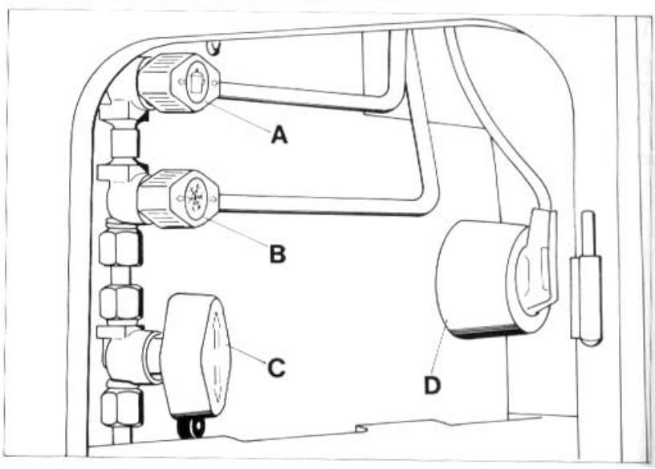
All vents are pictured in their OPEN setting.

A = Blocking vent for the cooker C = Main Blocking Vent
B = Blocking vent for the fridge D = 220v socket for the fridge
1.3 Gas Cooker

Warning ! Before opening the cooker cover, put the driver’s seat in a vertical position.

When cooking with high heat levels, the more powerful of the cooker hobs is on the left hand side.

To Switch On:
Open the vents in the cupboard, press the cooker knob in, and turn to the left. Light the gas with a match or lighter, the press in the cooker knob for about 10 seconds (to ensure it remains lit). If the flame goes out when you let go of the knob, repeat the process above for lighting, and hold in the knob for a little longer.
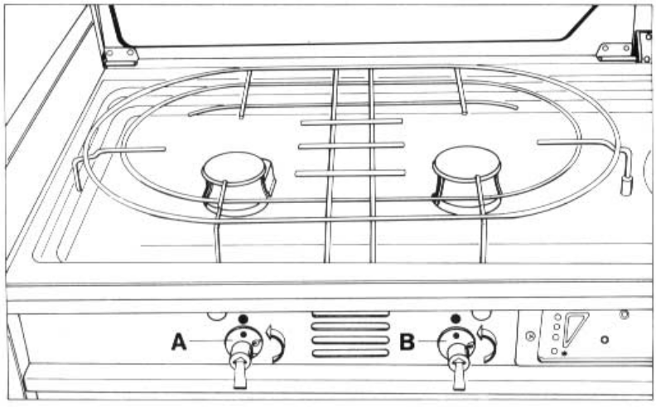
A = Strong Cooker B = Normal Cooker

To Turn Off:
Turn the cooker knob to 0, shut the barrier vent in the cupboard.

Warning ! When using the cooker, the air vents (windows) are not allowed to be closed. Open sources of heat should not be used to warm food.

1.4 Display
The cooker contains a display of the functions of:
(1) control display for the fridge’s use of gas / petrol
(2) water display of the fresh water tank
(3) second (leisure) battery charge level
(4) switch and LED (Control Lights) for the De-Icer
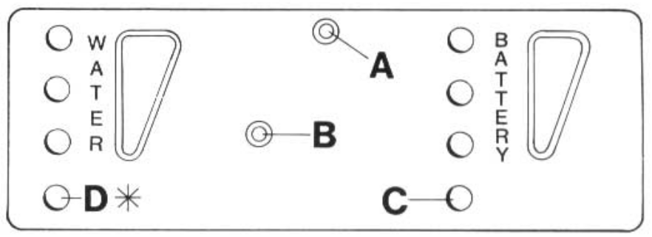
A = Switch for Control Light for Water, Battery Levels, and Petrol Usage of fridge
B = Switch De-Icer On/Off
C = Control Light for De-Icer
D = Control Light for Fridge

Switch (A) can be used to switch the control lights for filling the fresh water tanks, the petrol use of the fridge, and the charge level of the second battery On/Off.
1.5 Fridge

Before using the fridge for the first time, the inside of the fridge should be cleaned with lukewarm water and a mild cleaning fluid

Explanation of the controls

A – button to operate the fuse / ignition control

B – dial for the combined electric / gas thermostat.

The combined electric / gas thermostat can be used with the LPG or the mains electricity. The thermostat is not set up for use with 12v battery power. If the dial for the thermostat is turned fully to the left – past the point where you can feel some resistance – the mains use is switched off. This same dial position needs to be in the minimum setting for use with LPG (LPG use will only be switched off by switching the LPG connection to the fridge)

C to E – Buttons to switch the voltage on / off

C – Button for mains use

D – Button for 12V use

E – Button for LPG use

F – red signal light

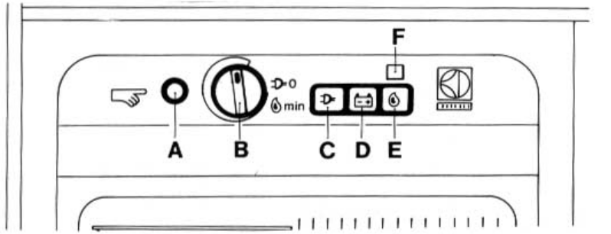

When in Use (220v)
Check if the voltage of the house or campsite mains connection is within the required voltage. This can be found inside the fridge at the top left. (The power surge protector must be switched on)

1. Press in Button (C)
2. Turn the combined electric / gas thermostat dial (B) to the max setting.
3. When not in use, switch off button (C) when using button (D) or (E).

When in Use (12V)
When using 12V, your fridge is protected by the general electrical circuitry of your vehicle. To prevent your vehicle’s battery from draining, a measure has been built into the 12V circuitry to ensure that the fridge can only be used when the vehicle’s engine is running.

The thermostat cannot be controlled when the fridge is running on 12V.
When in Use (LPG)
The fridge is designed for use with Propane or Butane gas only. Natural gas or city gas must not be used.

1. Open the vents (main vent of the gas lead, and quick close vent in the fridge)
2. Turn the thermostat knob (B) clockwise to the max setting.
3. Press in button (E). Straight after pressing the button, the electronic gas ignition will switch on, the red signal light will light up.
4. Press button (A) in and keep it pressed in. After 20-30 seconds, the burner will automatically ignite. As soon as the flame lights, the ignition will stop, and the red signal light will go out. Keep the button (A) pressed in for another 15-20 seconds, then the thermo-electric ignition from the LPG tank will stay open.

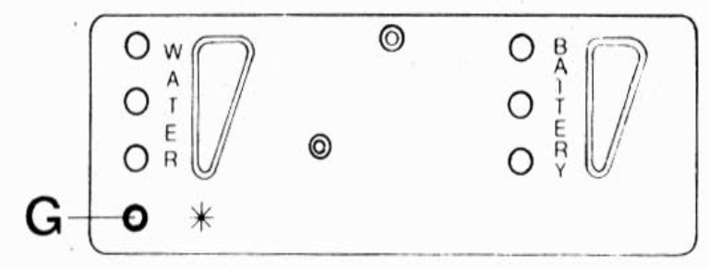

You can see the progress of the ignition steps by flashing light (F). The use of the burner flame is shown by control light (G) (see below) as long as switch (A) on the cooker display is switched on.

Should there be a cause (other than the LPG tank being empty) for the gas flame to go out, it will ignite again automatically. If it does not ignite due to a defect, the protection mechanisms will activate and will automatically shut off the LPG flow.

5. When not in use or if the fridge has a problem using gas, stop the gas flow to the fridge & switch off button (E) by using button (C) or (D).

Regulating the temperature of the fridge

You can regulate the temperature of the fridge by using the combined electric / gas thermostats. From the max position, you can turn the temperature knob (B) anticlockwise to your desired temperature.

Important Notice !

Always watch out that the fridge is never connected to 2 power sources (ie: gas & electricity) at the same time. It would then not work, and will cause damage. Such damage would not be covered by the warranty.
1.6 Electrics

12V / 220 V Appliances

The 12V appliances (water pump, heating, display, fridge, and ice-ex) are serviced by the second battery.

The lights in the living space are powered by the starter battery.

Important Notice !

12V Battery Use: Please note that the battery capacity is limited by leaving it for a while without recharging. For example, at least 11V is required for using the additional heater.

220V electrical appliances (max 2000 Watts) can be used with the internal plug sockets, as long as the socket on the outside of the vehicle has been connected to the mains.

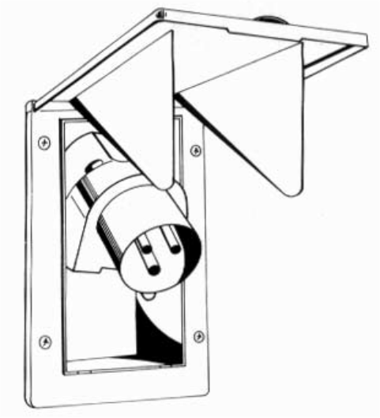

The external socket 220v – 16 Amps to CEE 17 (European Standards) is located on the external left hand side of the vehicle.

Important Notice !

Use with 220V: Attach the vehicle to the mains via the outside plug. You will find plugs for the battery charger and the fridge (with a similar one on the power surge protector)

Power Surge Protector

This is located near the floor next to the cooker, and serves as a power surge protector and power plug.

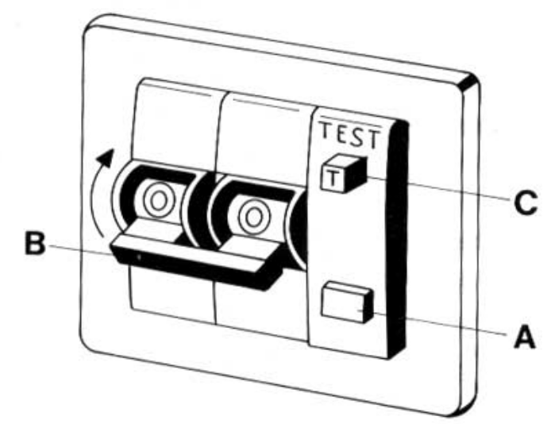
When In Use: Press in the blue button (A) until it clicks in, then bring the black switch (B) to the position (1) (ie: push up)

To Test Its Use: To test its use, 220V mains power must be connected to the vehicle. Press in the white test button (C), the blue button (A) should then pop out and the black switch (B) will go to the ‘O’ position.

Important Notice ! When the protector is not switched on, the electricity which is used by the 220V appliances (ie fridge, battery charger, and plug by the cooker) will not work.

Battery Charger:
The battery charger operates automatically. As soon as you have attached the 220V current to the vehicles external socket, the charger is ready for use. The charger status of the starter and second battery comes from electrics in the charger. The batteries are then charged up the max setting. Once the batteries are fully charged, the charger will switch itself off.

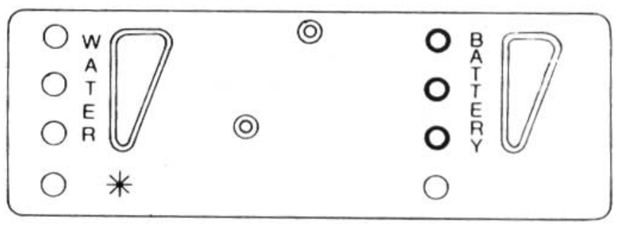

The 3 control lights on the right of the display show the charge status of the second battery.

Green = more than 12.5 volts
Yellow = less than 12.5 volts
Red = less than 12 volts
1.7 Water Source and Disposal

Filling the Water
The means to fill the water is lockable, and can be found on the left hand side of the vehicle (on the outside).
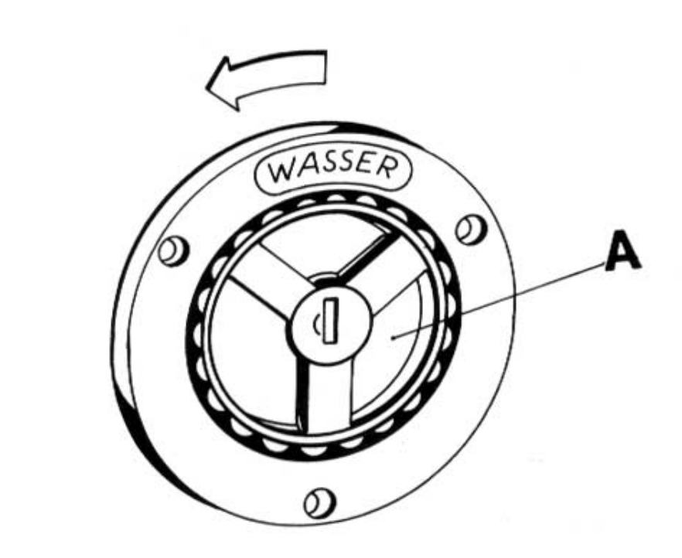
To Open:

Push (A) inwards and at the same time, turn in the direction of the arrow

Fresh Water Tank

The fresh water tank in then Joker is found under the seating. The cleaning, opening is accessed through the cover, under the seating.

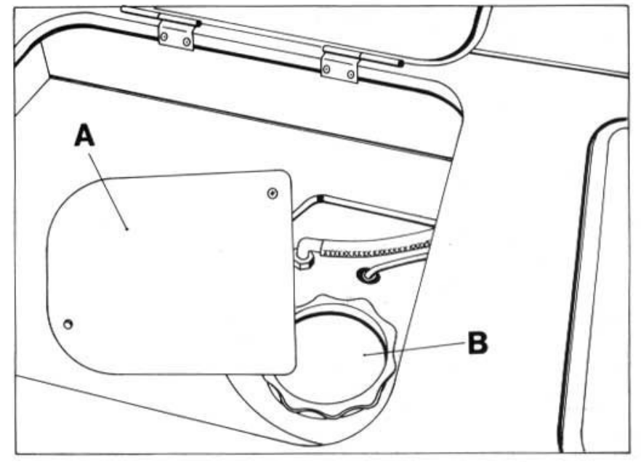

To Open:
- Take out one screw of the cover (A) and loosen the other screw.
- Push cover (A) top one side and turn the cleaner cover (B) to open.
To empty the fresh water tank, open the drainer (A) under the bottom of the vehicle (towards the driver’s side rear wheel).
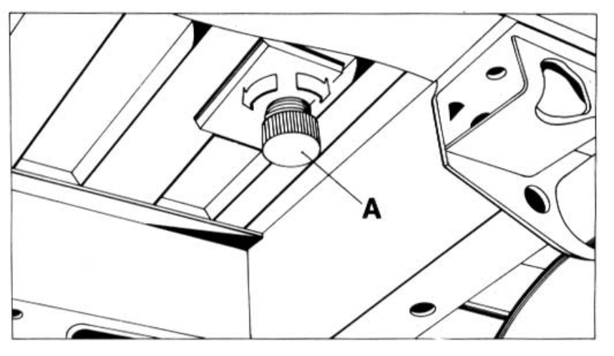

Sink:
The sink can be found under the cover of the kitchen equipment. By switching on the tap, the water pump in the fresh water tank will be switched on automatically.

A heat protector is situated under the cover on the left. After folding this down, when not in use, it can be used as a draining board.

Water Disposal

Waste Water Tank

Water will drain from the sink to the waste water tank. To empty the tank, open the waste tap (A). Clean the tank thoroughly through the cleaning opening (B).
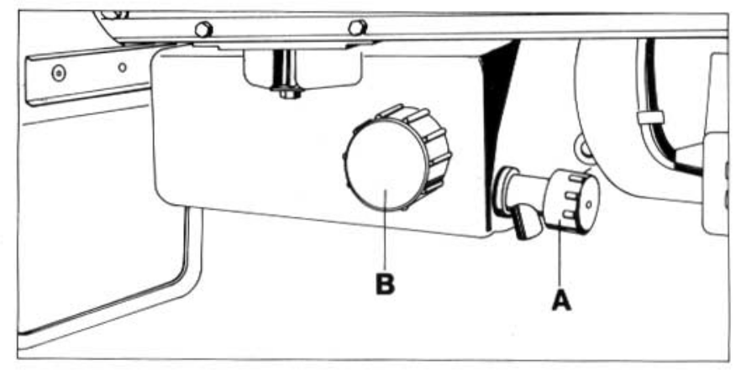

Instruction:
Please note the camping site’s rules on waste when emptying the tank.

Warning !
It is absolutely necessary to empty the whole water system when not in use in the winter (where danger of frost exists).

1.8 Seats and Beds

Front Seats:

Please see the vehicle manual for use of the front seats.

Westfalia - Luxury Seats

To adjust the seats:

- Take weight off the back of the chair, and pull (A) handle
- Put back of chair to the desired position and let go of (A). The seat will click into place.
- (C) is to adjust the distance of the chair to the front.
- To adjust the armrests, turn the knob (B).
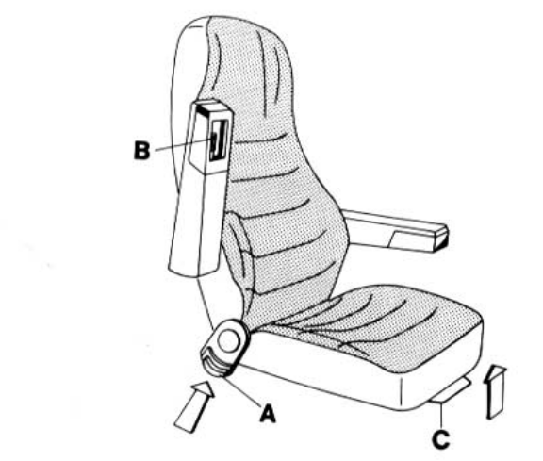
Seating in the Back

There is storage space under the rear seat. This is accessible by propping up the seat cover. Secure the seat cover with (B).
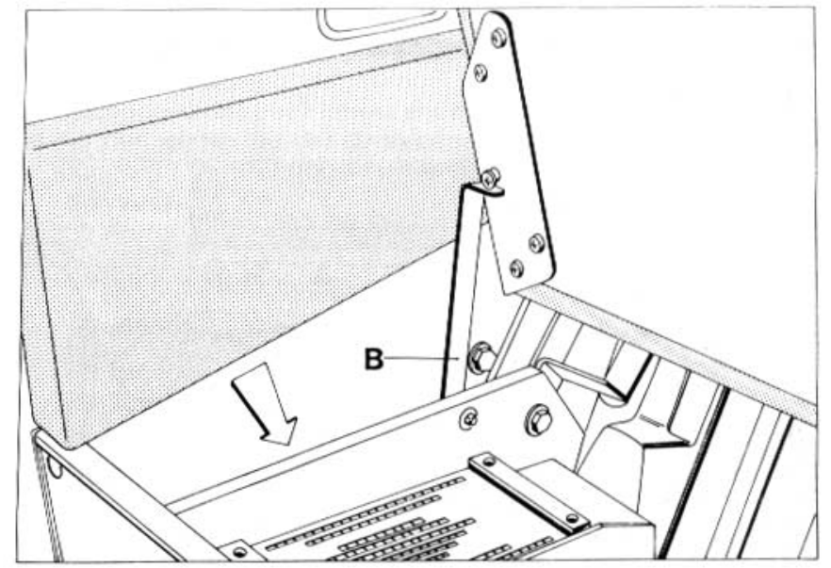

Warning !

Between the back and the wooden wall (where the arrow is) is where the heating escapes. To prevent overheating, this space must not be covered. The battery charger cannot be covered.

To Lower the Bed:
If the back seats are equipped with head rests, these need to be removed before building the bed.

To Build:
- Loosen the seats by pulling Knob (A).
- Pull the seats up slightly and forwards.

The back seat will then fall into the bed position. This will then form the double bed.
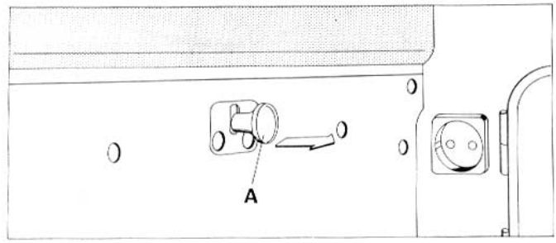
To Return Seats to the Seating Position:
- Pull the seats up by 90 degrees until they click into place.
- Put the seats back, until they are secured into place.

Note: In the flooring of vehicles with a PVC Floor, there are tracks to secure a middle seat. Where a middle seat is built in, the lower double bed cannot be used.

Setting up the Double Bed in the Roof Area:
The roof area / loft must be set up as follows:
- Pull the upper bed unit about 10 cm forward and fold down.

To Put Back
- Fold the bed unit at the front down, and push back.

Double bed in the high roof vehicles
To assemble the bed into position:
- Loosen Locks
- Pull the bed extension forwards at the same time
- Put in the middle cushion

To put the bed away, do the above steps in reverse.

Note: If there are no safety belts / secures for children, small children should sleep in the lower beds.
Warning ! During the journey, no-one should occupy the upper beds.

1.9 Tables
Table
- Loosen the table by the dials (A) & (B)
- Adjust the table to the required position
- Secure using the dials (A) & (B)
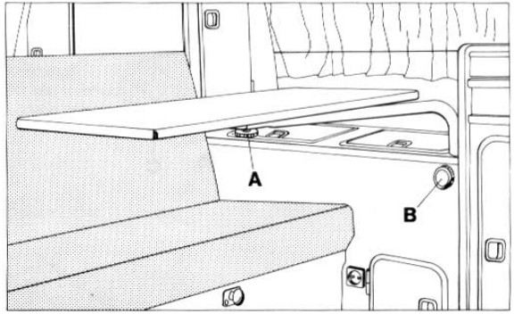
Folding Table
To Set Up
- Pull up Table (A) from the grip (below left) with a light pull
- Pull up Table (A) and loosen the stand (B) from the grip (C)
- Push the stand (B) down & put the table in the desired position
- Turn the stand (B) to secure in the hole (D) in the vehicle’s floor

To put back, follow the above steps in the reverse order
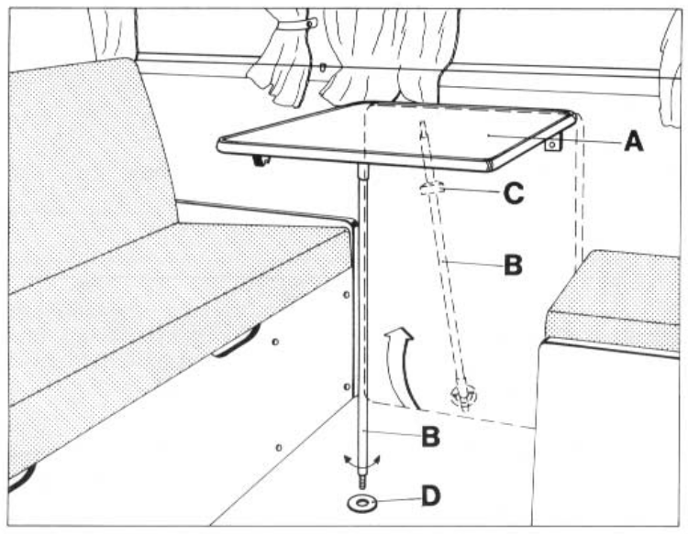
Warning !
When setting up and taking down the table, beware of the length of the stand
  - Pop Up roof with Storage Space
To prevent creating a vacuum when setting up the roof, you need to open a door or window prior to setting up. Similarly, when closing the roof, the air must be able to escape to prevent any damage from the material blowing out and getting caught.

To Open
- Open the lock by pushing back the lock (A) in the direction of the arrows
- Push up the roof as far as possible
- For the last part of setting up the roof, use the stand and press this forward until it locks into place.
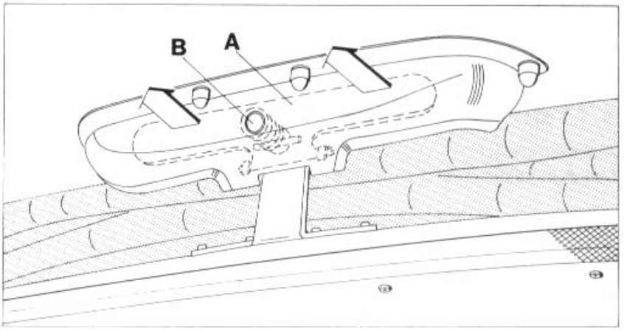
To Close
- Push the stand back and under, and close the roof about 20 cm
- Pull the material forward in the corners C&D
- Fold the material to prevent it getting caught
- Pull the roof down with the grips, until (A) closes (you will hear this) and secure locks (B)
- Look in area (E) to ensure the material has not got stuck / jammed anywhere
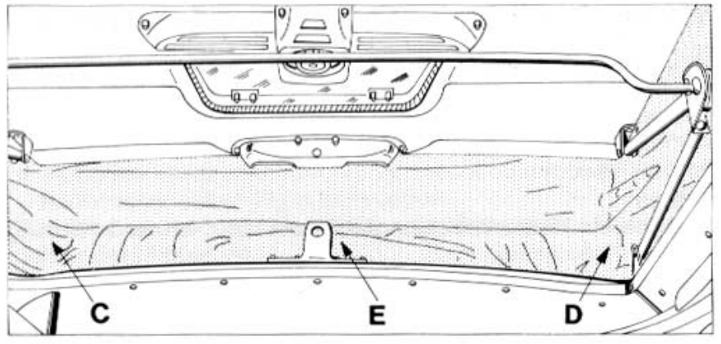

Warning !

To prevent damages, the vehicle must not be driven with an open roof.

1.11 Airing The Van / Windows
Window
The window can be opened without supports
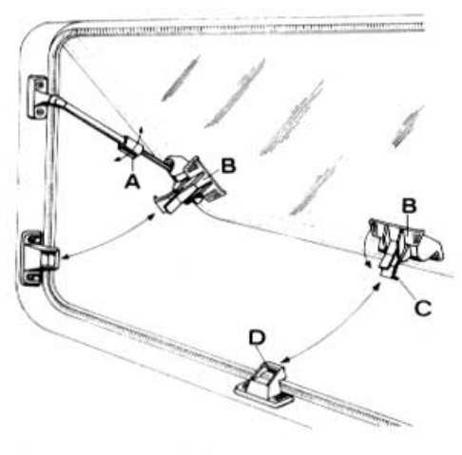
Diagram in the OPEN position

To Open
- Lift the lever of the locks up completely to the desired setting
- Turn the stabilisers (A) to secure

To Close
- Levers (B) of the 3 locks need to be open
- Stabilisers (A) on the side supports need to be loosened, by turning either to the left or right
- Close the window
- Press the levers (B) in, so the clip (C) lies behind the latch (D)
Warning ! The window should not be open when driving.
Sun Roof

To Open
- Turn dial (A) to the right in the direction of the arrow >>to open<< (AUF = OPEN)
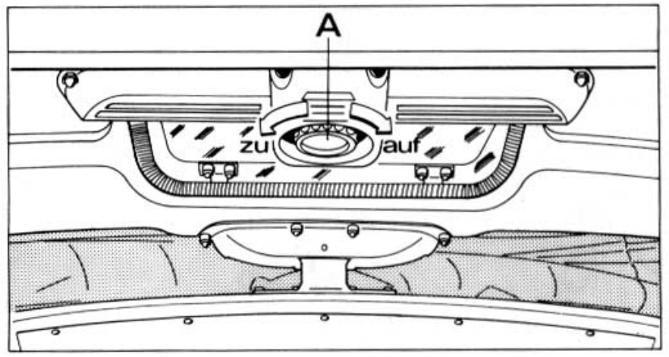

To Close
- Turn dial (A) to the left in the direction of the arrow >>to close<< (ZU = CLOSE)

Roof Vents

Turn the lever (A) to open or close the roof vents.
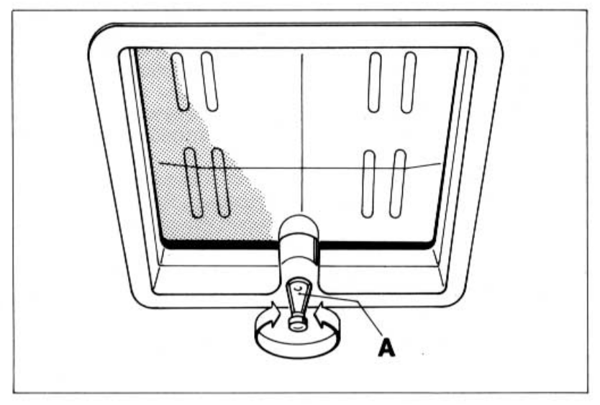

Warning !

To avoid any damage, the roof vents should stay closed during the journey.

Camper Van Curtains:
- Hang the curtains on the buttons / poppers.
- To secure the curtains at the front, fold down the sun blinds.

Furniture Locks

To open doors, flaps, cupboards, drawers, or the lid of the kitchen appliances, pull the grip in the direction of the arrow.



